|  |  |  |  |  |  |
| --- | --- | --- | --- | --- | --- |
| Date | 8-Dec-22 | | | Tester Name | Andrew McLaughlin |
| Environment | Penfax - Test | | | Login used |  |
| Operating System | Windows | Version: | Update: | | |
| Software Used | Edge | Version: | Update: | | |
| Select Software | Version: | Update: | | |
| Release version | 22.4.1 | | | | |
| Title | M44.02 Penfax Locks and Unlocks Properly | | | | |
| Test Type | Regression | | | | |
| Test Scenario | M44.02 Penfax Locks and Unlocks Properly | | | | |
|  |  | | | | |
| Expected Results |  | | | | |
| Pass/Fail | Pass | | | JIRA# | N/A |

Describe your steps with screenshots:

After performing the Pre-Payroll Runs (44.01), add a Monthly Production payroll batch for all plans except PEPP/WCB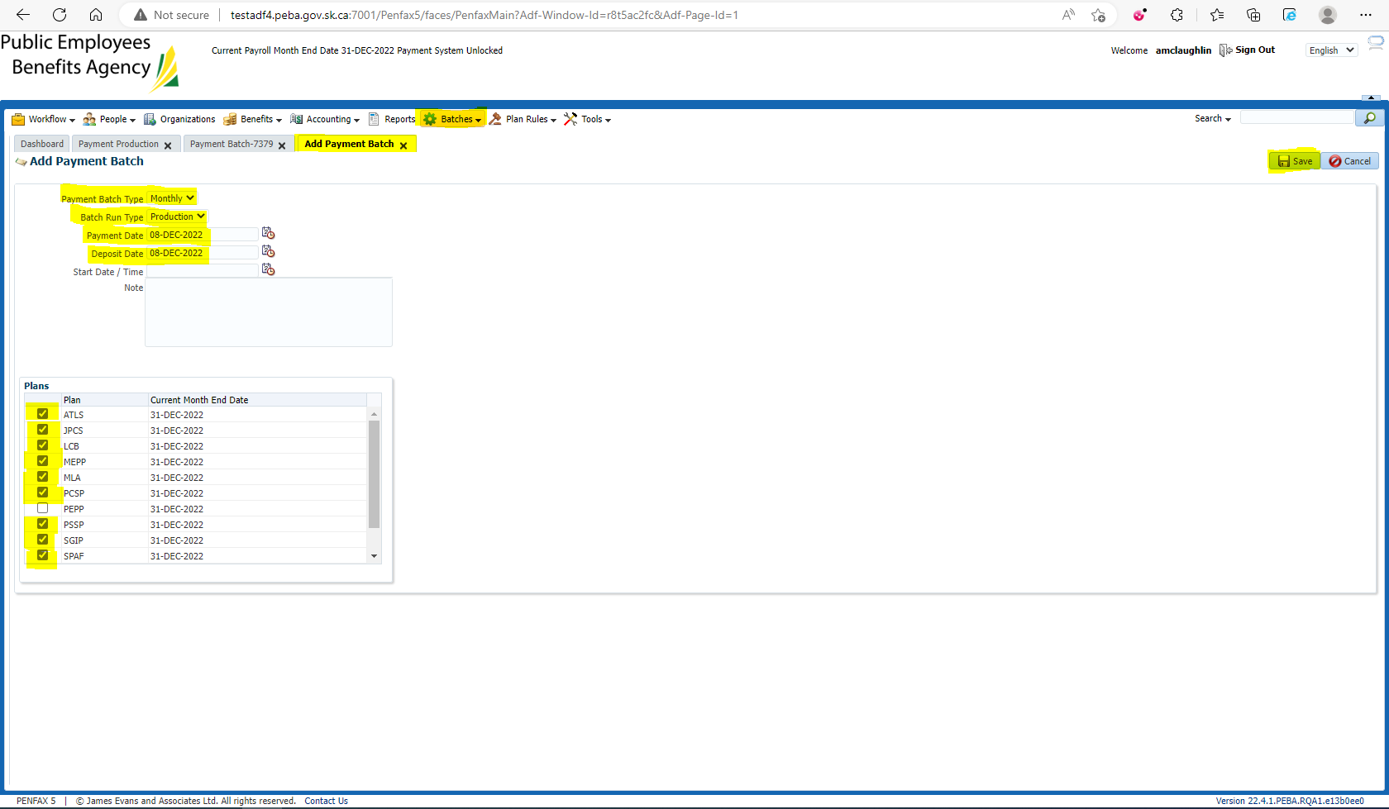

Once the payroll batch has been Completed successfully, Process the batch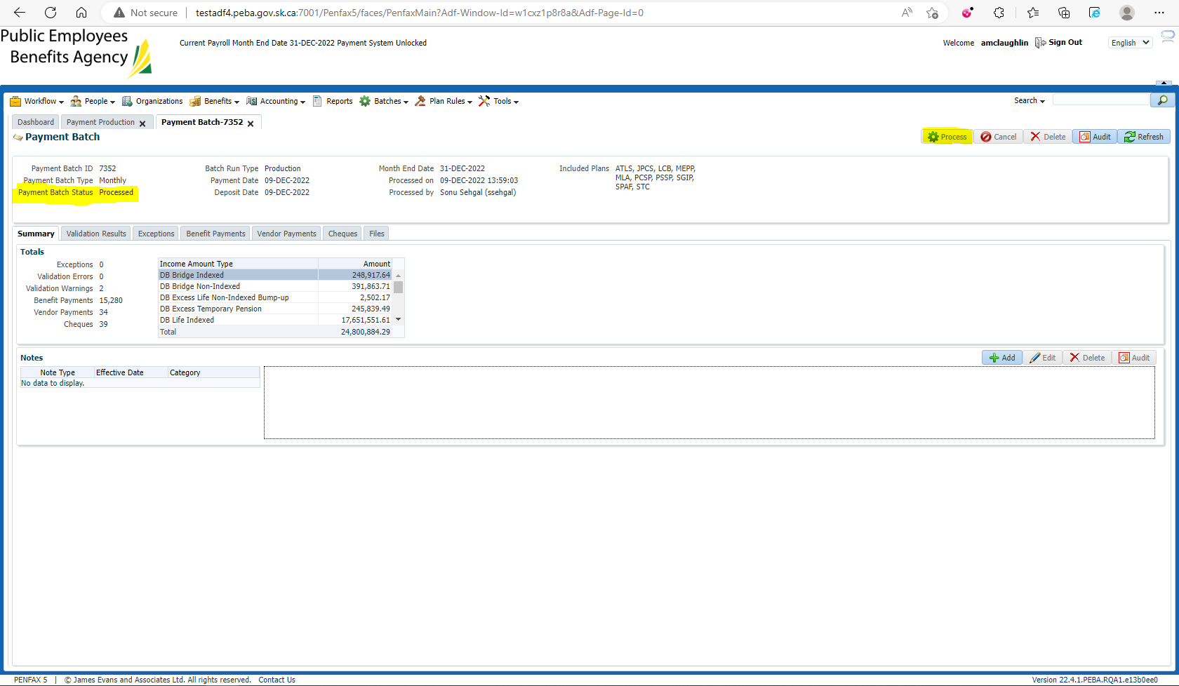

Once the batch has been processed, check the Payment Production tab to ensure that the Payment System has locked and unlocked properly